
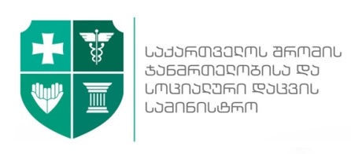




Conference: “Promoting Cancer Prevention and Early Detection Measures in Georgia”

Friday, 9th of September, 2016
Venue: Zugdidi Municipality City Hall, 45, Gamsakhurdia Ave., Zugdidi

(Working language – Georgian with English Translation)

15:00 – 15:30 | Registration and Welcome Coffee
15:30 – 16:00 | Opening speeches:  Tomáš Pernický  H.E. The Ambassador of the Czech Republic in Tbilisi  Valeri Kvaratskhelia  Deputy Minister of Labour, Health and Social Affairs of Georgia  Evžen Diviš  Caritas Czech Republic, Regional Manager for Mongolia, Caucasus and Balkans  Rema Ghvamichava  Director of Georgian National Screening Center  Givi Javashvili (Facilitator)  Tbilisi State Medical University, Head of Department of Family Medicine  Levan Shonia  State Representative – Governor In Samegrelo-Upper Svaneti Region  Irakli Gogokhia  Mayor of Zugdidi Municipality City Hall  Giorgi Todua  Acting head of Zugdidi Municipality City council
16:00 – 16:10 | Speaker: Nana Mebonia, MD  National Center for Disease Control and Public Health  Head of Department of Chronic Diseases  “National Cancer Control Strategy”
16:10 – 16:30 | Speaker: Rema Ghvamichava, MD  Georgian National Screening Center, Director  The State Cancer Screening Programs in Georgia – Current Situation and Issue of Geographic Accessibility to the State Programs in Regions
16:30– 16:50 | Speaker: Lubomir Skopal, MD, Maria Skopalova, MD  Caritas Czech Republic, Invited experts  Cancer Screening Programs in Czech Republic
16:50 – 17:00 | Questions & Answers
17:00 – 17:20 | Speaker: Ioseb Abesadze, MD  Cancer Prevention Center, Director  Project results: Promoting the Role of Primary Health Workers in Cancer Prevention and Early Detection Strategy and Palliative Care
17:20 – 17:35 | Speaker: Kakhaber Akhvlediani, MD  Tanadgoma - Center for Information and Counseling on Reproductive Health  Project Coordinator  Project results: Importance of Raising Cancer Awareness about Cancer in the Population – Overcoming Cancer Related Stigma
17:35 – 17:45 | Special Address: Mzia Kvirkvelia  “Winner Women’s Club”, Lanchkhuti Branch  Cancer patient
17:45 – 18:00 | Discussion and closing remarks
18:00 – 19:00 | Lunch

